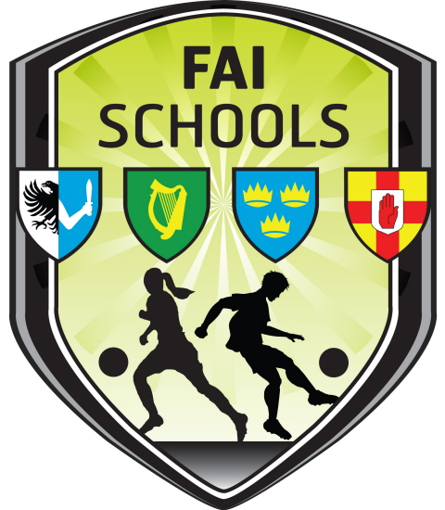

FAI Schools Leinster Branch
Girls Section

Dear Teacher,

In preparation for an up-coming U15 Girls Schools International tournament next year, our Association will be holding an Under 15 Interprovincial competition for girls in early November. This Interprovincial competition will be a crucial part of our selection process for our FAI Schools International squad.

An important first step in this process will be the selection of a Leinster Schools squad. All schools in Leinster, regardless of being affiliated to the FAI Schools, are invited to nominate players to attend initial trials in this regard. When considering nominations please be mindful of the following issues.

Nominated players must be of exceptional ability. We are looking initially for the best in Leinster, but ultimately for the best in Ireland. We would not expect more than 3 nominated players from any school.

Schools are not obliged to nominate anybody. This is initially trial process and not a coaching session. It would be helpful for all concerned if players nominated have a realistic chance of selection.

As the Interprovincial tournament is a schools competition, nominations can only be made by the SCHOOL a player attends not by clubs or leagues.

This is an Under 15 competition.

Nominated players must be born on or after January 1st 2002.

Nominated players must be available on all of the following dates:

Sat September 17th: Initial Leinster Trial.

Venue: St Killians DSD Secondary School, Clonskeagh, D14. Time: 10:00 am – 1pm (approx).
Bring playing gear, water, additional footware suitable for astro turf and light rain jacket.

Sat September 24th: Final trial

Sat: October 1st: Squad training.

Sat: October 8th: Squad Training

Sat: October 15th: Squad Training

Sat October 22nd: Squad Training/ Match

November 5th: Final Training/Match

November 11th to 13th inclusive: Interprovincial tournament. Games will be played Friday, Saturday and Sunday on a round-robin basis.

The FAI Schools International management team will attend the Interprovincial weekend and will subsequently select a squad of players to begin training for the International Tournament.

Please be sure to bring these dates to attention of nominated players before they attend trials. Unavailability for genuine or exceptional reasons should be made known to me on contact number provided.

We thank you for your co-operation and look forward to receiving your nominations for this year.

Nominations should be emailed to paul.howard@faischools.ie. Please include the following details:

Player(s) name, school, date of birth, playing position and name of nominating teacher/coach.

Paul Howard: 087-9186979

